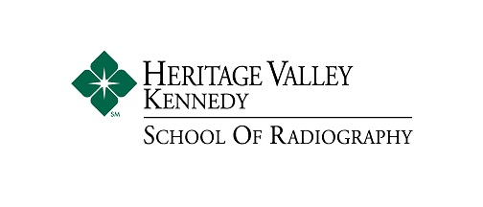
Admissions Checklist for Prospective Students
Heritage Valley Kennedy Hospital/La Roche University Radiography Program
Step One: Initial Contact
- Contact Mrs. Buchholz, B.A., R.T. (R), Clinical Coordinator, to schedule your Career Shadow opportunity. (Required for admission)
- Phone: 412-777-6200, Email: mbuchholz@hvhs.org

Step Two: Apply to La Roche University
- Indicate Radiologic Technology as your designated major. Apply online at www.laroche.edu.
- You must be accepted to La Roche University prior to applying to Heritage Valley Kennedy Hospital. Acceptance to La Roche University does not guarantee acceptance to the Hospital.
- You will receive a letter officially admitting you to La Roche University.

Step Three: Apply to Heritage Valley Kennedy Hospital, School of Radiography
- Complete an application.
If your application is incomplete, no action will be taken until it is complete.
- You will be contacted by Mrs. Fazio, School of Radiography Director, for a personal interview.
- If accepted, you will receive an official letter of acceptance from Heritage Valley Kennedy Hospital.
- If you are not accepted, please contact your La Roche University counselor to discuss your options. You may want to switch majors and pursue a different career path.

Step Four: Deposits
- Send a deposit to both La Roche University and Heritage Valley Kennedy Hospital to hold your place.
Check your acceptance letter for the specific amount and due date.

