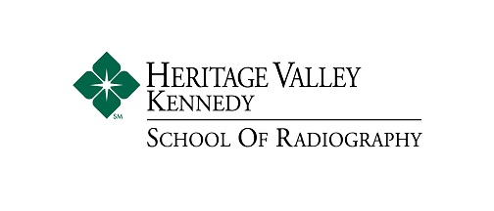
Shadow Request
Thank you for your interest in Heritage Valley Kennedy Hospital’s, School of Radiography! All interested applicants must complete a career shadow at Heritage Valley Kennedy before applying to the program. Career shadows are available Monday through Friday from 7:30 AM to 12:00 PM. Those interested in completing a career shadow must be at least a junior in high school. Please bring this signed form with you on your shadow appointment.

To request a career shadow opportunity, please contact:
Megan Buchholz, B.A., R.T. (R)
Clinical Instructor, Heritage Valley Kennedy Hospital, School of Radiography
mrussell@hvhs.org, 412-777-6200

If you are under the age of 18, please have your parent or guardian sign the
following Confidentiality Pledge:

Confidentiality Pledge
As a shadow student at Heritage Valley Kennedy Hospital. I hereby agree:
That I will uphold patients’ rights to privacy against disclosure of personally identifiable medical and social information, as assured to patients under the Patient's’ Bill of Rights and the HIPAA Privacy Regulations.

That I will not divulge any information concerning patients, their conditions, treatments, diagnoses or personal background, or any other confidential or non-public information concerning patients, Heritage Valley Kennedy Hospital, or its staff, which I acquire through my shadow assignments, to anyone.

That I will not divulge or misuse any such information at any time during the term of my shadow assignment or after such service ends.

______________________________________ _______________________
Shadow Student’s Signature Date

______________________________________ _______________________
Parent’s Signature, if under the age of eighteen Date

______________________________________ _______________________
Representative, Heritage Valley Kennedy Hospital Date

