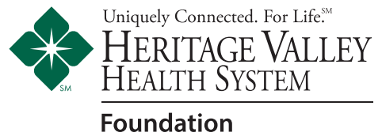
Sponsorship

A Spirited Evening
Presented by The Clerici-Larkin Group pf Baird Private Wealth Management
Saturday, April 6, 2024  7:00 pm – 10:00 pm  Hyatt Regency - Pittsburgh Airport
A night of fine cuisine, wine, craft beer & cocktails! Proceeds benefit the Heritage Valley Health System Foundation

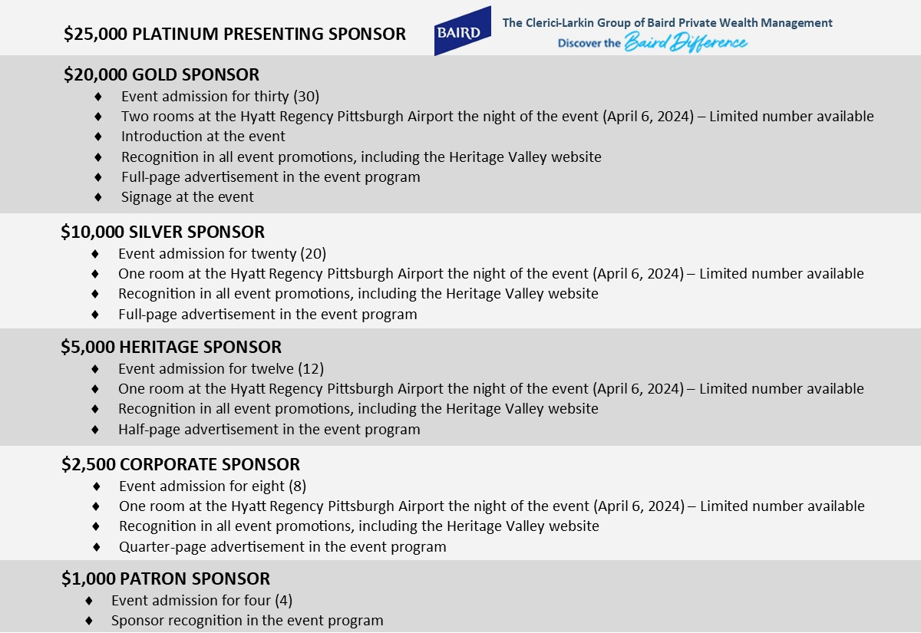

Contact Name: Company Name:
Address:
City: State: Zip Code:
Phone: Fax: ________________
Email: ________________
Make checks payable to: Heritage Valley Health System Foundation, 420 Rouser Road, Suite 102, Moon Township, PA 15108
DISC VISA M/C AMEX
Name on Card: Card #:
Expiration Date: Security Code:
Total amount enclosed: $ Total amount to be invoiced: $
Phone: 412.749.7121 Fax: 412.749.6761 Email: kanastas@hvhs.org

