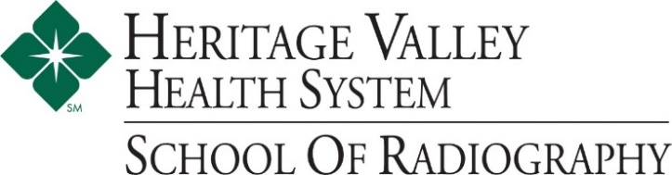

Admissions Checklist for Prospective Students
Heritage Valley Health System/La Roche University Radiography Program
Step One: Initial Contact
- Contact Mrs. Buchholz, B.A., R.T. (R), Clinical Coordinator, to schedule your Career Shadow opportunity. (Required for admission)
- Phone: 412-777-6200, Email: mbuchholz@hvhs.org

Step Two: Apply to La Roche University
- Indicate Radiologic Technology as your designated major. Apply online at www.laroche.edu.
- You must be accepted to La Roche University prior to applying to Heritage Valley Health System, School of Radiography. Acceptance to La Roche University does not guarantee acceptance to the Hospital.
- You will receive a letter officially admitting you to La Roche University.

Step Three: Apply to Heritage Valley Health System, School of Radiography
- Complete an application.
If your application is incomplete, no action will be taken until it is complete.
- You will be contacted by Mrs. Fazio, School of Radiography Director, for a personal interview.
- If accepted, you will receive an official letter of acceptance from Heritage Valley Health System, School of Radiography.
- If you are not accepted, please contact your La Roche University counselor to discuss your options. You may want to switch majors and pursue a different career path.

Step Four: Deposits
- Send a deposit to both La Roche University and Heritage Valley Health System, School of Radiography to hold your place.
Check your acceptance letter for the specific amount and due date.

